MACH4METAL

metalworking machinery
Transito 21
6909 DA BABBERICH Netherlands
Tel. +31 (0)316-247123
Fax: +31 (0)316-247956
info@mach4metal.com
www.mach4metal.com

Bank No : 66.52.13.883
IBAN : NL33 INGB 0665 2138 83
BIC : INGBNL2A

HAEUSLER 4 roller 5000 x 40 mm
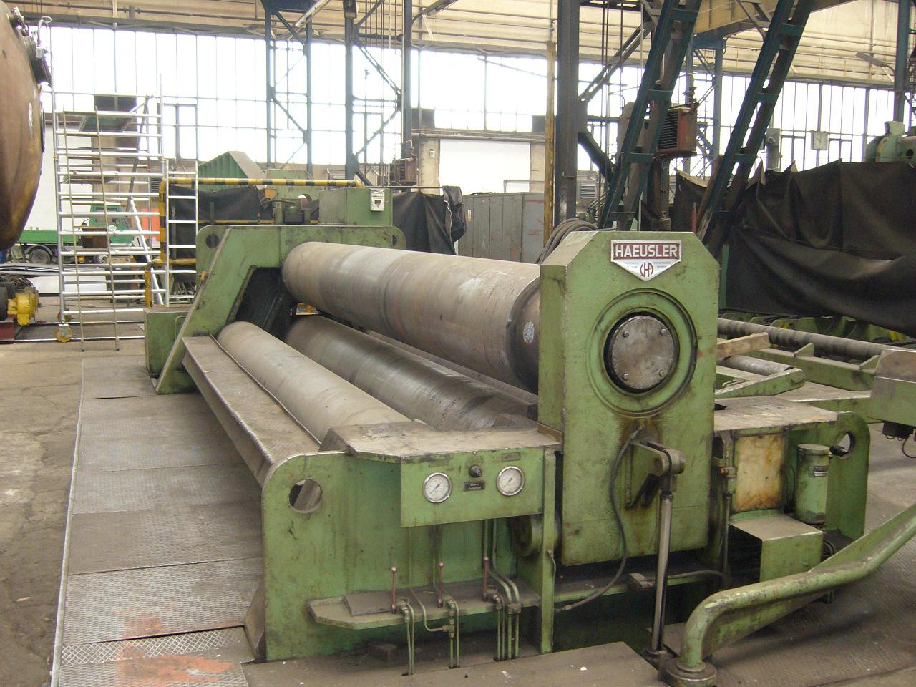

- Make : HAEUSLER SWISS
- Typ : VRM HY
- Serial No : WO 1576
- Age : 1983

- Bending length : 5.000
- Roll length : 5.200

- Ø 2500 Bending thickness : 40 mm
- Ø 2500 pre bending : 30 mm
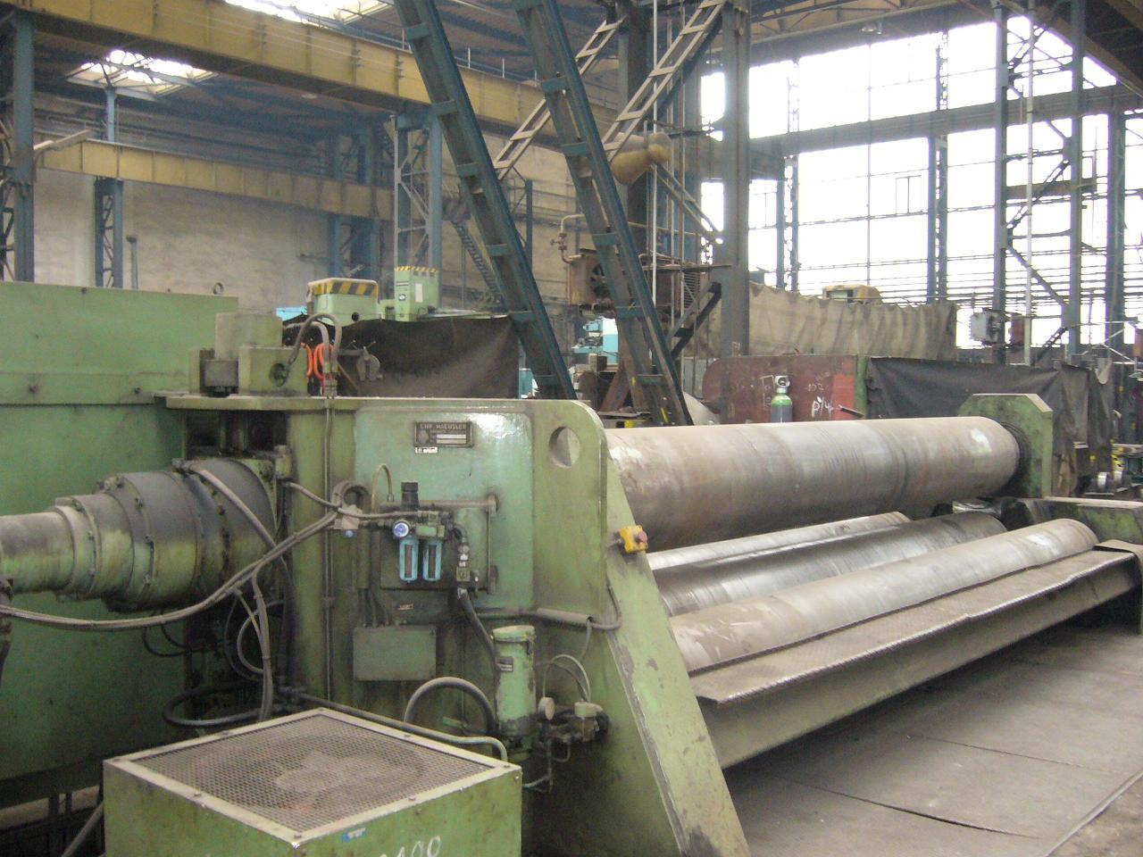

- Top roll Ø : 570
- Lower roll Ø : 570
- Side roll Ø : 460
- Max. Distance top / lower : 220

- Working speed: 2 – 6 Vario
- 2 roll hydraulic drive total 75 kW

- Side support Ø 2000 x 5 Ton
- Top support Ø 3500 x 5 Ton
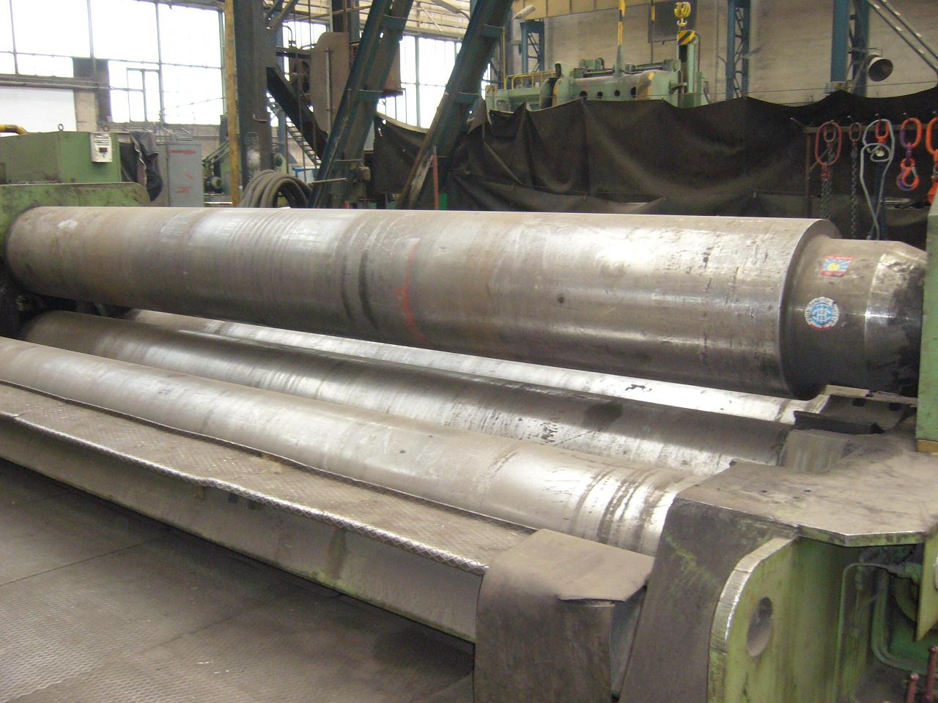

- Extra spare top roll Ø 380
- Minimum bending Ø : 425
- 4 x optical read out position roll
- Hardened 65 Mn Crmo4 900 – 100N/mm

- Length : 8.300
- Width : 2.820
- Height : 3.200
- Weight : 53.700 Kg

Please Note: The above information has been obtained to the best of our ability and belief from, and from the manufacturers where possible. It is given in good faith, but its accuracy can not be guaranteed. Accordingly, it will not form a representation or constitute contractual terms. We advise you to check any vital details!

